Network Cable Types and Tool Theory
- List 3 key differences between Ethernet cables and fiber optic cables, and give one real-world example where each type would be used (for example, home WiFi router, data center, college campus backbone).

Table1: Ethernet Cable vs Fiber Optic Cable
Ethernet Cable | Fiber Optic Cable
Uses copper wires to send data. | Uses light signals through glass or plastic fibers.
Best for short distances (up to about 100 m). | Best for long distances (several kilometers).
Lower speed than fiber. | Very high speed and high bandwidth.

Real-World Examples:
- Ethernet Cable: Used to connect a home Wi-Fi router to a desktop computer or gaming PC.
- Fiber Optic Cable: Used as the college campus backbone or in a data center for high-speed communication.

- Draw and label a diagram showing the internal wiring of a straight-through Ethernet cable (use T568B wiring standard), indicating the color of each wire and its pin number.
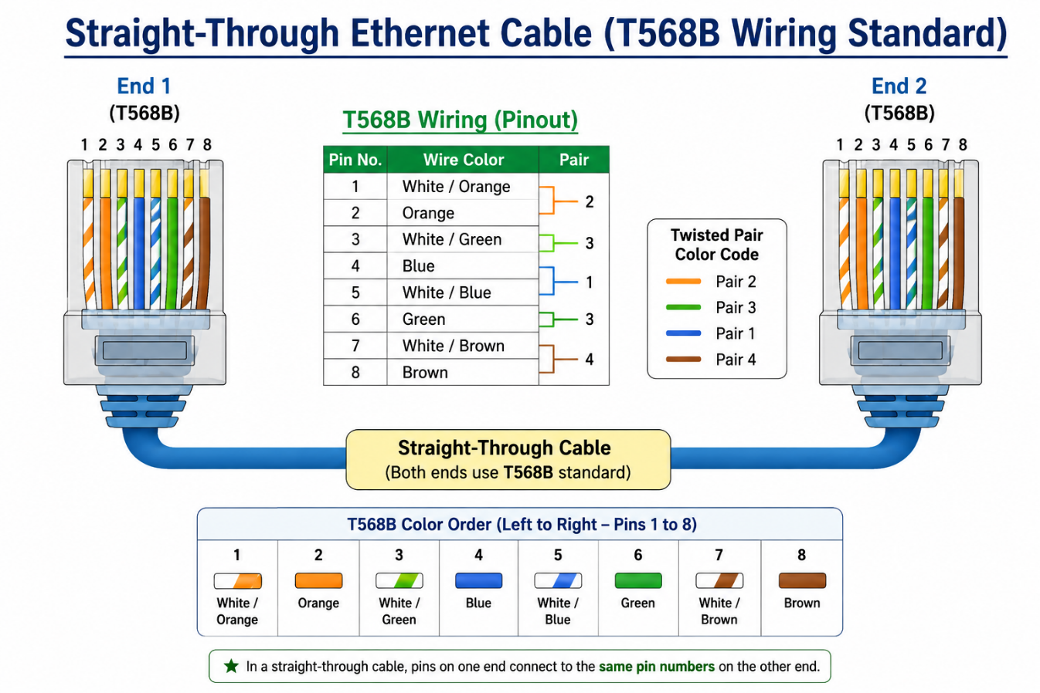Fig 1. T568B Straight-Through Ethernet Wiring Guide

- Watch a YouTube video demonstrating how to use an RJ45 crimper, then write a step-by-step guide (in your own words) on how to attach an RJ45 connector to a CAT6 cable.

- Cut the CAT6 cable
- Use a cable cutter to cut the cable evenly.
- Why: A clean cut makes it easier to attach the connector.
2. Strip the outer jacket
- Use a wire stripper to remove about 2–3 cm of the outer cover.
- Why: This exposes the eight internal wires.
3. Untwist the wire pairs
- Separate and straighten the eight wires.
- Why: Straight wires are easier to arrange correctly.
4. Arrange the wires in T568B order
- Put the wires in this order (left to right):
  - White/Orange
  - Orange
  - White/Green
  - Blue
  - White/Blue
  - Green
  - White/Brown
  - Brown
- Why: Correct order ensures proper network communication.
5. Trim the wires evenly
- Cut all eight wires to the same length (about 1.2–1.5 cm).
- Why: All wires must reach the end of the RJ45 connector.
6. Insert the wires into the RJ45 connector
- Carefully slide the wires into the connector while keeping the color order.
- Ensure the cable jacket also goes slightly inside the connector.
- Why: This provides a secure and reliable connection.
7. Crimp the connector
- Place the RJ45 connector into the RJ45 crimping tool and squeeze firmly.
- Why: The crimper locks the connector and makes electrical contact with the wires.
8. Test the cable
- Use a network cable tester to check both ends.
- Why: This confirms that all eight wires are connected correctly and the cable works properly.

- Imagine you are setting up a gaming café with 10 PCs for LAN gaming. Decide which cable type (Ethernet or fiber optics) and which tool (RJ45 crimper or fiber cleaver) you would use, and explain your choices in 3-4 sentences. Hint: Consider speed, distance, and budget for your answer.

For a gaming café with 10 PCs, I would use Ethernet (CAT6) cables because all the computers are close to each other. Ethernet cables are fast, reliable, and less expensive. I would use an RJ45 crimper to attach the RJ45 connectors to the cables. I would not use fiber optic cables because they are more costly and are mainly used for very long-distance connections.

